index_layout.jpg -Home page with “About”, Featured products, and introductions to site content

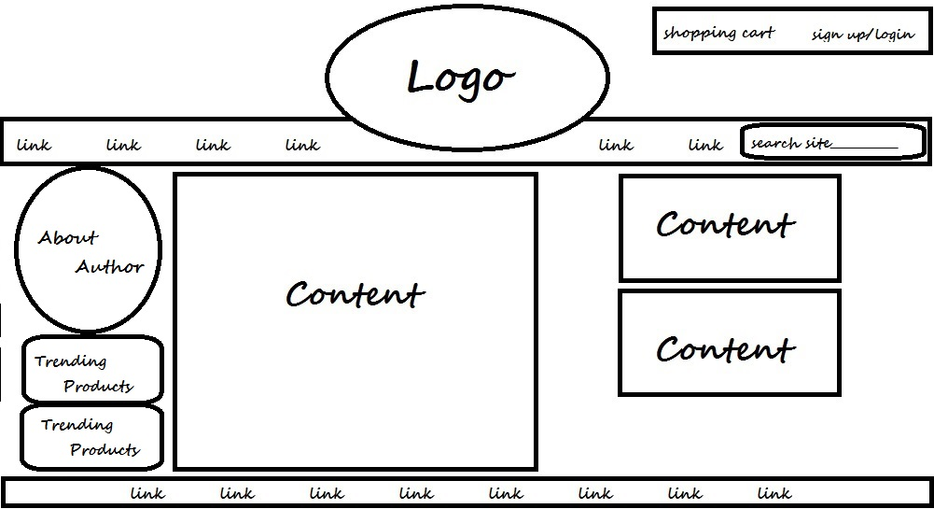

Sales_layout.jpg -Sales page, organized by category, with individual product thumbnails

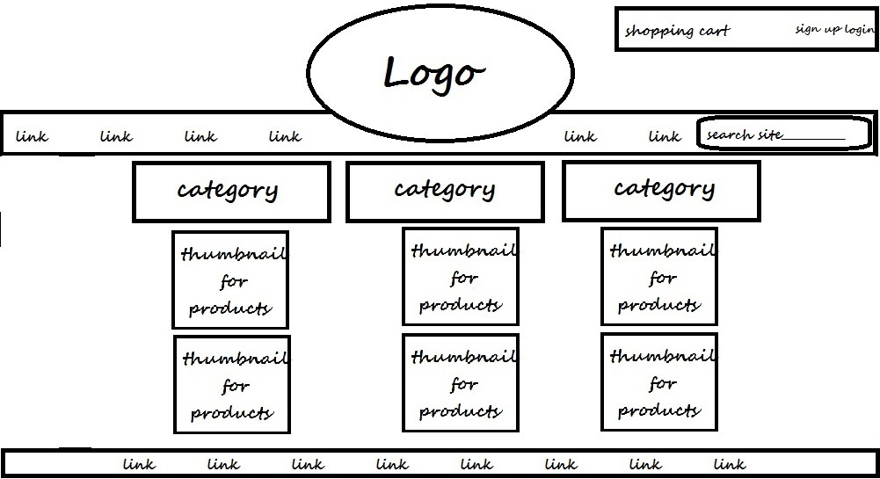

Product_detail_layout.jpg -Individual product pages

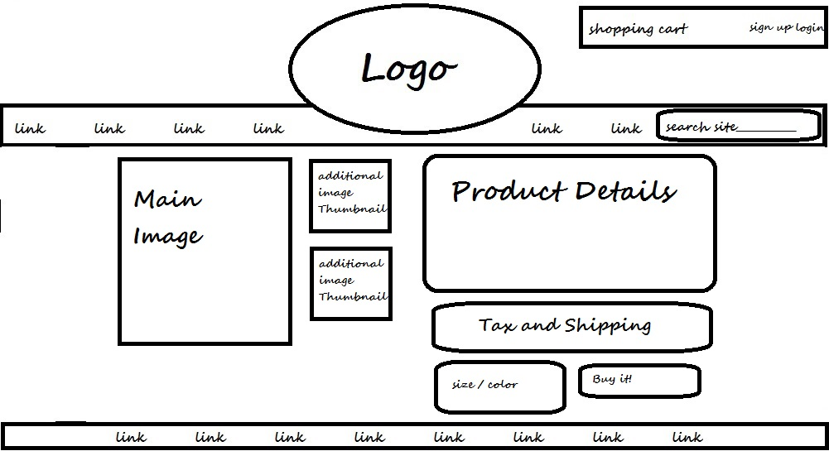

Blog_layout.jpg -Blog and tutorial pages with featured products and outside advertising

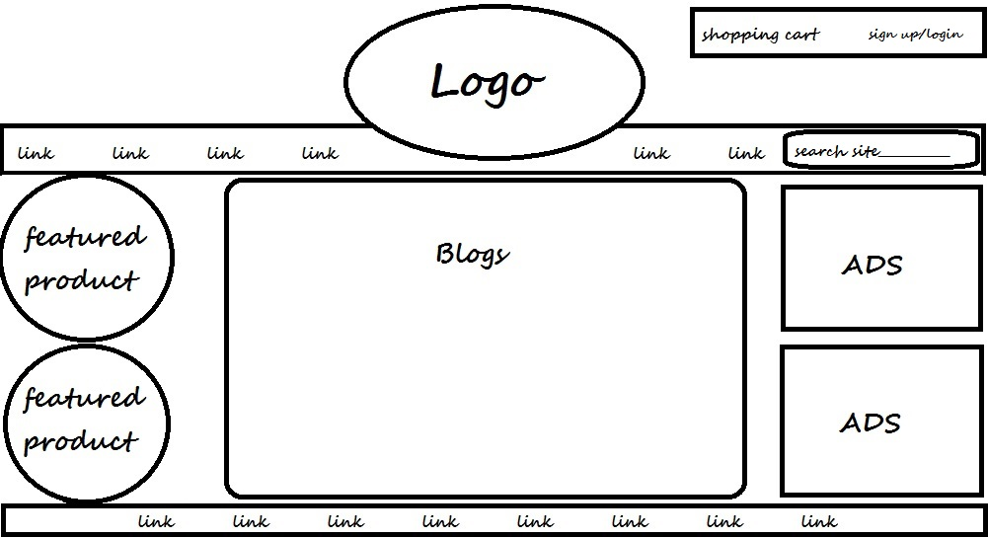

List_info_layout.jpg -Class/ program/ website/ or contact information for various criteria

